Activity 2

Question 1

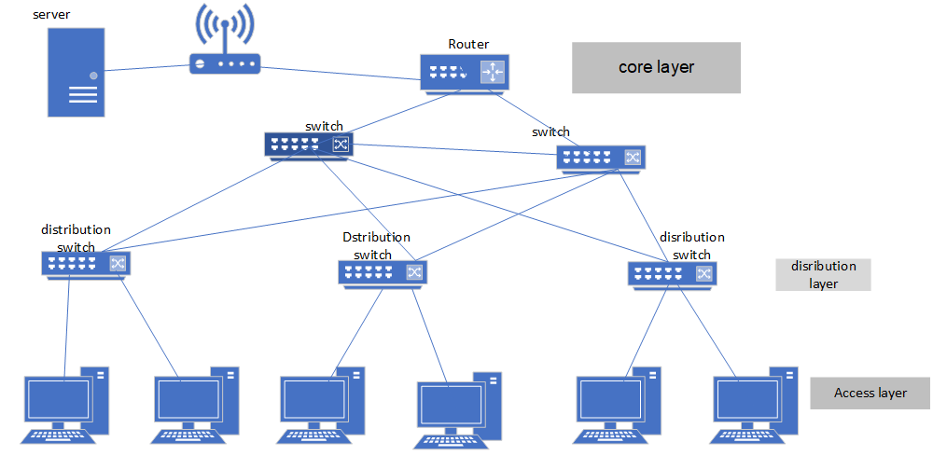

Question 2

Switching loops can be prevented using the Spanning Tree Protocol (STP). Spanning Tree Protocol aims to choose the fastest network path when there are redundant links in the network. Spanning Tree Protocol (STP) is a Layer 2 network protocol used to prevent loopsin a network topology. STP was created to avoid problems that occur when computers exchange data on a local network (LAN) with redundant paths. STP protects the Layer 2 Broadcast domain from broadcast storms by selectively placing links in standby mode to prevent loops. In inactive mode, these links temporarily stop thetransmissionof user data. If the topology changes so that data transmission is possible, the links are automatically reactivated**. ( TechTarget, 2023)**

Activity 3

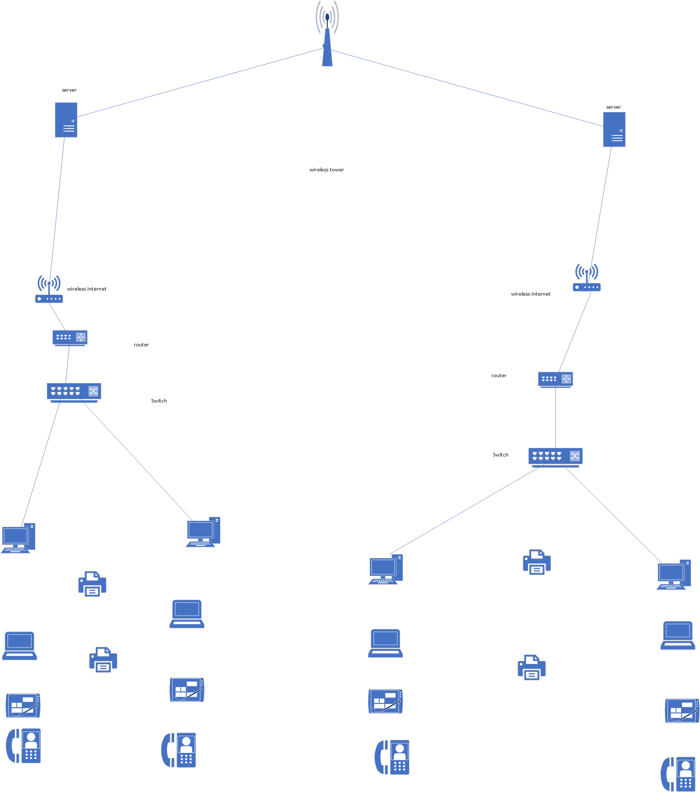

Activity 4

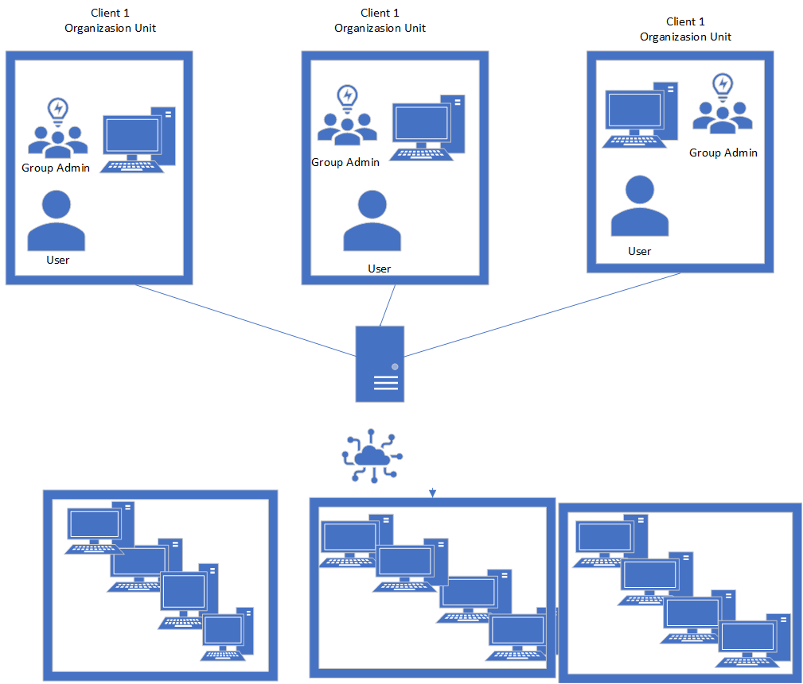

Referencing

https://www.techtarget.com/searchnetworking/definition/spanning-tree-protocol